Load Balancing Configuration
MikroTik

SUBASH SUBEDI
INFO@SUBASHSUBEDI0.COM.NP

Abstract
This project focuses on designing and implementing a dual-WAN load balancing system using MikroTik RouterOS 7.x with the Per Connection Classifier (PCC) technique. The complete network topology-consisting of two ISP connections, a MikroTik router, and multiple LAN clients-was built and simulated using GNS3 with real MikroTik CHR images. The purpose of this setup is to distribute traffic evenly across two WAN links, increase overall bandwidth efficiency, and provide automatic failover in case of link failure. All configurations were performed, tested, and validated within the GNS3 environment, ensuring the solution is accurate, repeatable, and suitable for real-world deployment.

Table of Contents
1. Objective 3
2. Network Topology 3
3. Configuration Steps 3
3.1. Create LAN Bridge 3
3.2. Assign LAN & WAN IP Address 4
3.3. Configure DHCP Server for LAN 5
3.4. Configure WAN DHCP Clients (No Auto Routes) 7
3.5. PCC Mangle Rules 8
3.5.1. Accept Traffic Returning from WAN 8
3.5.2. PCC Connection Marking 9
3.6. Routing Table 10
3.7. NAT (Masquerade) 11
3.8. DNS 12
4. Verification Commands 13
5. Optional: Weighted Load Balancing (Example: ISP1 = 100 Mbps, ISP2 = 50 Mbps) 13
6. Conclusion 14

Objective
Implement reliable dual-WAN load balancing with automatic failover using the PCC (Per Connection Classifier) method. This configuration provides:
Approximately 50/50 traffic distribution (or weighed if required)
Full bandwidth utilization of both ISP links
Connection persistence (same connection always uses the same WAN)
Automatic failover and failback

Network Topology
Interface | Role | IP Assignment | Example IP | Gateway
Ether1 | WAN1 | ISP 1 | 192.168.1.89/24 | 192.168.1.254
Ether2 | WAN2 | ISP 2 | 192.168.174.133/24 | 192.168.174.2
Bridge1 | LAN | Static LAN | 192.168.88.1/24 | 192.168.88.1/24

Configuration Steps

Create LAN Bridge
We create bridge1 and add ether3–ether10 as bridge ports. This makes all LAN interfaces behave as one unified switch, simplifying management and ensuring all local devices share the same network.

/interface bridge
add name=bridge1 comment="LAN Bridge"

/interface bridge port
add bridge=bridge1 interface=ether3
add bridge=bridge1 interface=ether4
add bridge=bridge1 interface=ether5
add bridge=bridge1 interface=ether6
add bridge=bridge1 interface=ether7
add bridge=bridge1 interface=ether8
add bridge=bridge1 interface=ether9
add bridge=bridge1 interface=ether10

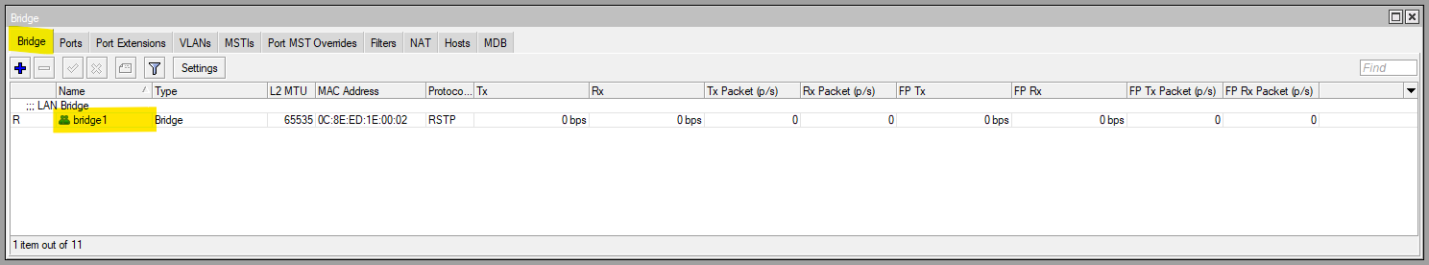
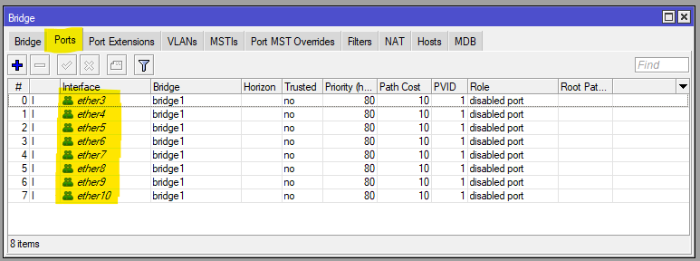
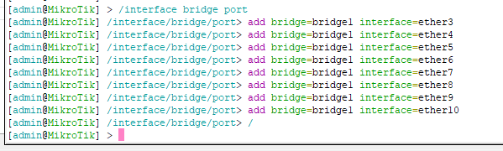

Assign LAN & WAN IP Address
We assign the bridge a fixed IP address (192.168.88.1/24). This becomes the default gateway for all LAN devices and the management IP for the router.
/ip address
add address=192.168.88.1/24 interface=bridge1 network=192.168.88.0
add address=192.168.174.134/24 interface=ether1 network=192.168.174.0
add address=192.168.1.89/24 interface=ether2 network=192.168.1.0
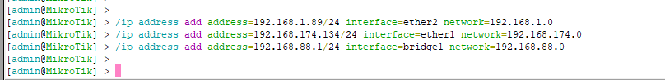
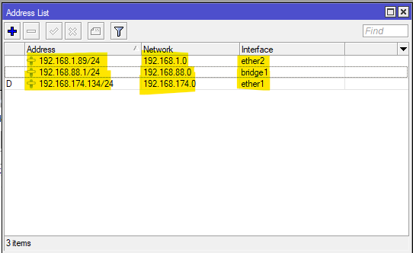

Configure DHCP Server for LAN
The DHCP server automatically provides IP addresses, gateway, and DNS information to client devices. This allows laptops, desktops, and mobile devices to connect without manual configuration.
/ip pool
add name=lan-pool ranges=192.168.88.10-192.168.88.254

/ip dhcp-server
add name=dhcp-lan interface=bridge1 address-pool=lan-pool lease-time=1d

/ip dhcp-server network
add address=192.168.88.0/24 gateway=192.168.88.1 dns-server=1.1.1.1,8.8.8.8

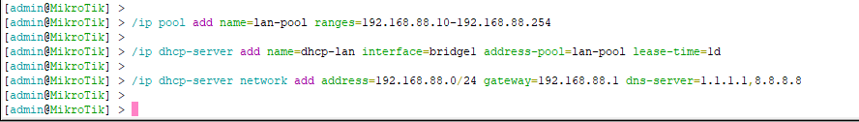
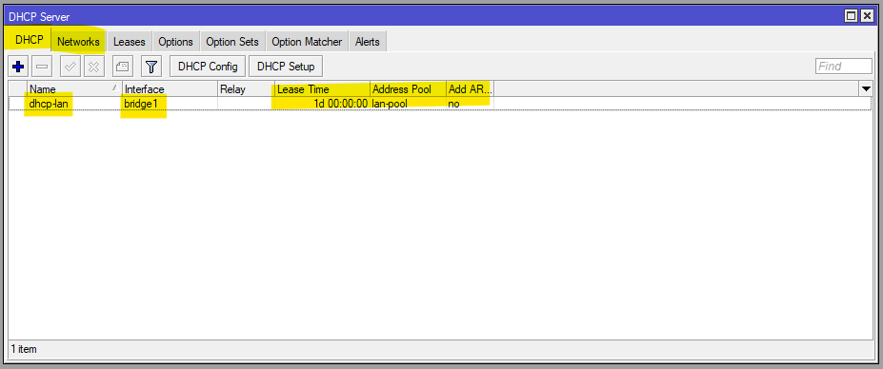
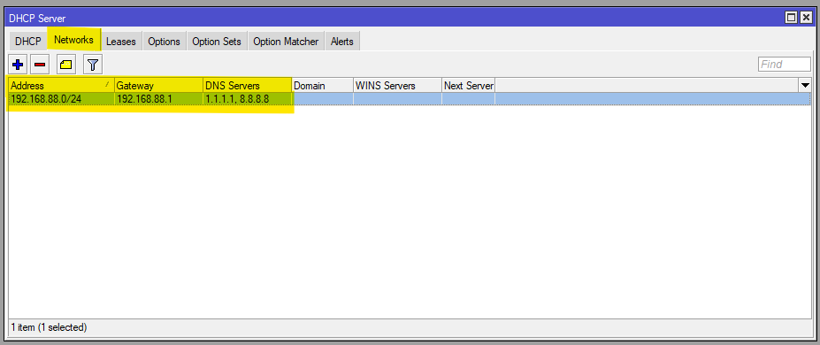
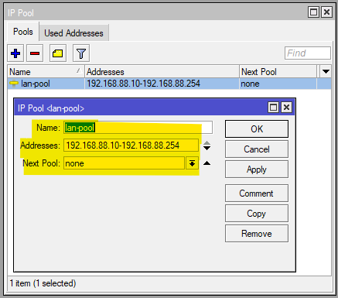

Configure WAN DHCP Clients (No Auto Routes)
Each WAN interface receives an IP address and gateway from its ISP using DHCP. We disable automatic default routes because PCC will control routing manually to achieve proper load balancing.
/ip dhcp-client
add interface=ether1 add-default-route=no use-peer-dns=no use-peer-ntp=no disabled=no
add interface=ether2 add-default-route=no use-peer-dns=no use-peer-ntp=no disabled=no

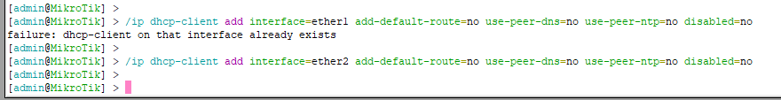
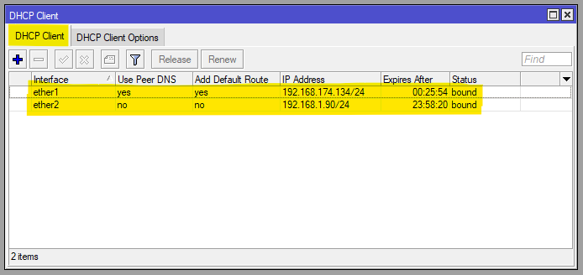

PCC Mangle Rules
Two mangle rules classify new connections and divide them equally between ISP1 and ISP2. PCC uses source/destination addresses and ports to evenly distribute traffic while keeping each session on one ISP.

Accept Traffic Returning from WAN
/ip firewall mangle add chain=prerouting action=accept dst-address=192.168.88.0/24 in-interface=ether1
/ip firewall mangle add chain=prerouting action=accept dst-address=192.168.88.0/24 in-interface=ether2

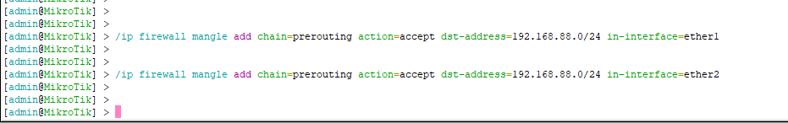
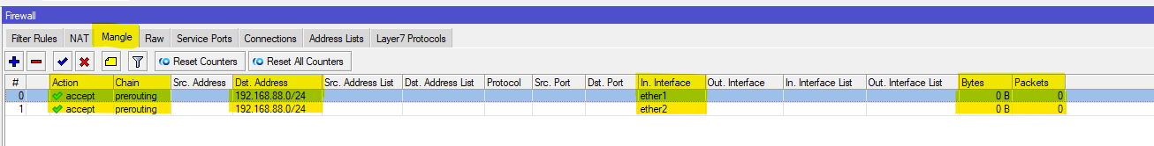

PCC Connection Marking
Two mangle rules classify new connections and divide them equally between ISP1 and ISP2. PCC uses source/destination addresses and ports to evenly distribute traffic while keeping each session on one ISP.
/ip firewall mangle add chain=prerouting in-interface=bridge1 dst-address-type=!local \ per-connection-classifier=both-addresses-and-ports:2/0 \ action=mark-connection new-connection-mark=ISP1_conn passthrough=yes

/ip firewall mangle add chain=prerouting in-interface=bridge1 dst-address-type=!local \ per-connection-classifier=both-addresses-and-ports:2/1 \ action=mark-connection new-connection-mark=ISP2_conn passthrough=yes

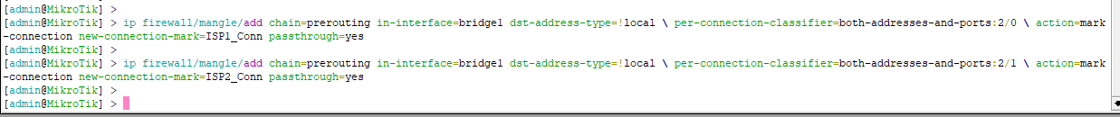
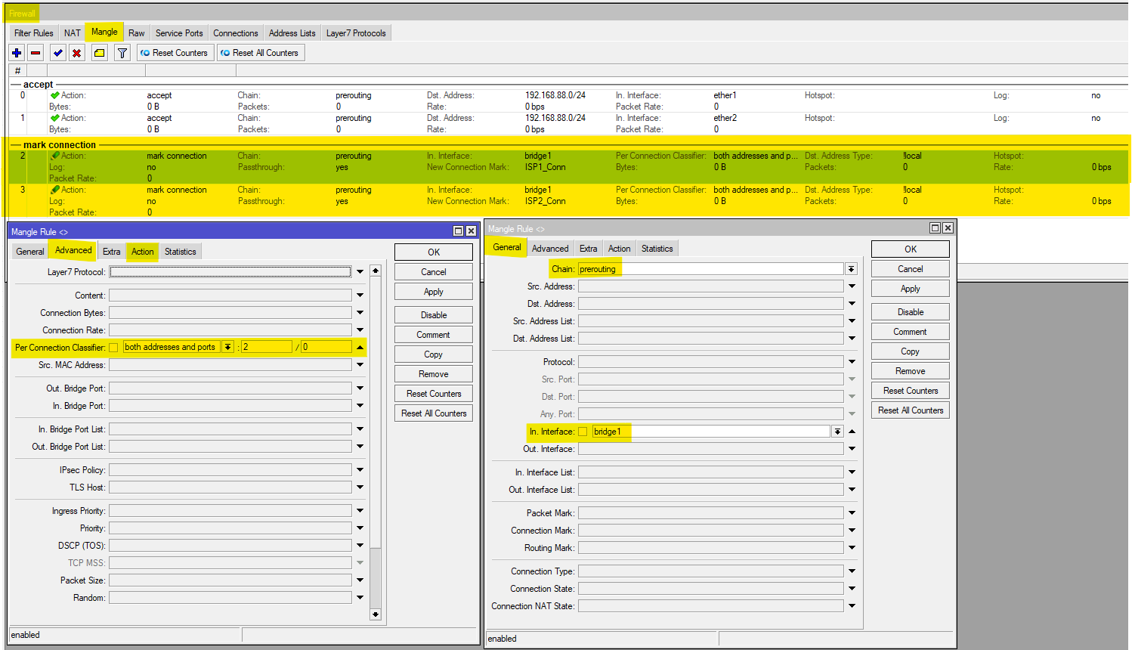

Routing Table
Routing marks are added to match the connection marks. This tells the router which ISP a specific connection should use and ensures consistent path selection. We add separate default routes for marked traffic, each pointing to its respective ISP gateway. Using check-gateway=ping allows automatic detection of link failure and ensures marked traffic avoids a down ISP. Two normal default routes are added with different distances (1 and 2). These routes are used by the router’s own services-such as DNS, updates, and WinBox-and also act as failover paths if one ISP becomes unreachable.
/ip route
add gateway=192.168.1.254 routing-mark=to_ISP1 check-gateway=ping distance=1
add gateway=192.168.174.2 routing-mark=to_ISP2 check-gateway=ping distance=1

add gateway=192.168.1.254 distance=1 check-gateway=ping comment="Primary WAN"
add gateway=192.168.174.2 distance=2 check-gateway=ping comment="Backup WAN"

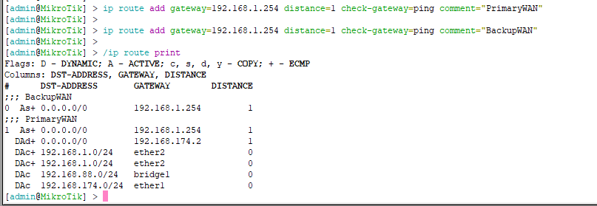

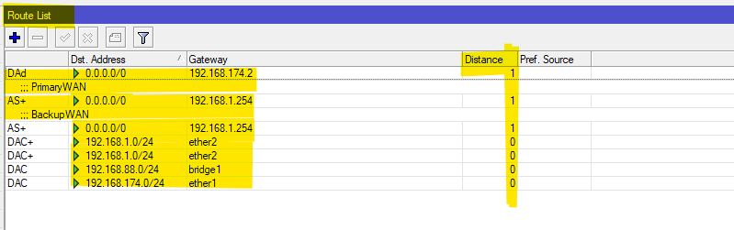

NAT (Masquerade)
Masquerade translates private LAN IP addresses to the ISP’s public IP on each WAN. This ensures return packets are routed back correctly and allows all users to access the internet.
/ip firewall nat
add chain=srcnat out-interface=ether1 action=masquerade comment="NAT ISP1"
add chain=srcnat out-interface=ether2 action=masquerade comment="NAT ISP2"

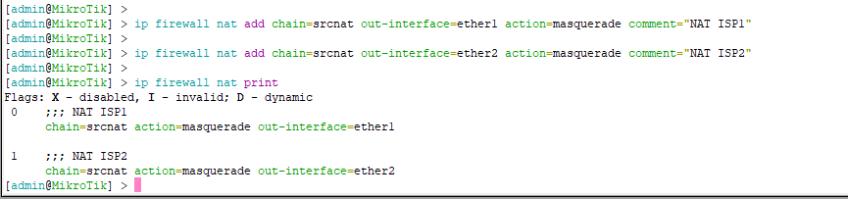
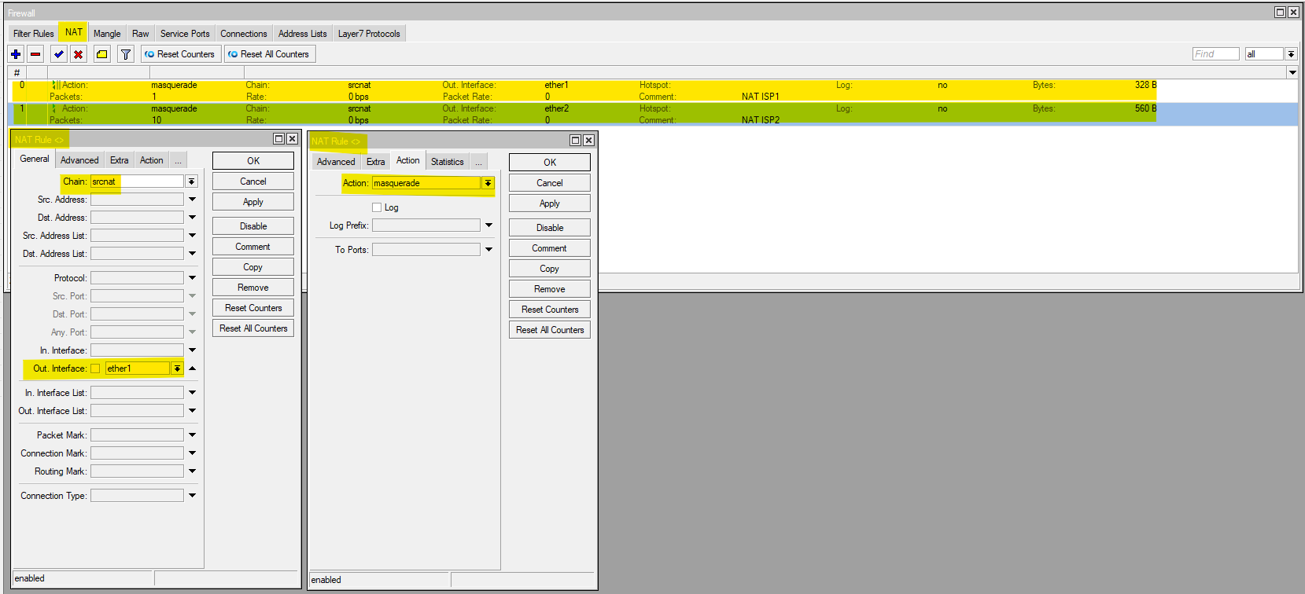

DNS
We set reliable public DNS servers (such as 1.1.1.1 and 8.8.8.8) and enable “allow-remote-requests” so the router can answer DNS queries for LAN clients, improving speed and reliability.
/ip dns
set allow-remote-requests=yes servers=1.1.1.1,8.8.8.8 cache-size=8192

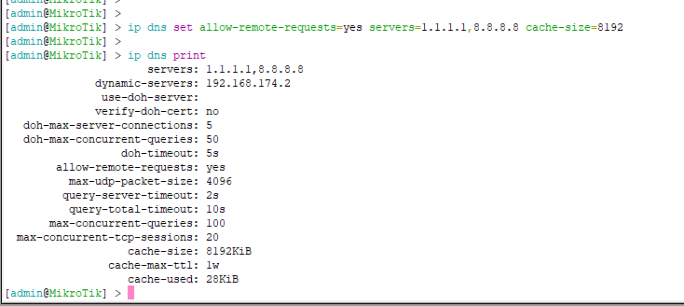
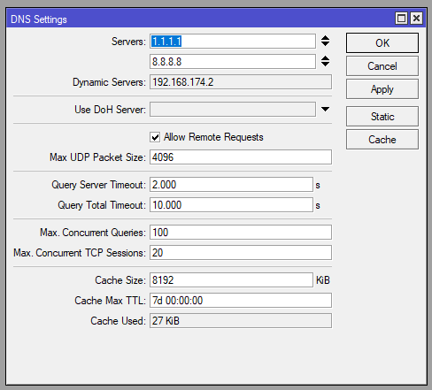

Verification Commands
/ip firewall mangle print stats # Should show balanced traffic
/ip route print where routing-mark~"to_" # Confirm routing entries
/ping 8.8.8.8 interface=ether1 # Test ISP1 link
/ping 8.8.8.8 interface=ether2 # Test ISP2 link
/tool torch interface=ether1 # Live traffic usage
/tool torch interface=ether2

Optional: Weighted Load Balancing (Example: ISP1 = 100 Mbps, ISP2 = 50 Mbps)
per-connection-classifier=both-addresses-and-ports:4/0 --- > ISP1_conn
per-connection-classifier=both-addresses-and-ports:4/1 --- > ISP1_conn
per-connection-classifier=both-addresses-and-ports:4/2 --- > ISP2_conn
per-connection-classifier=both-addresses-and-ports:4/3 --- > ISP2_conn

Conclusion
The implementation of MikroTik dual-WAN PCC load balancing in the GNS3 simulator was successful and met all expected objectives. The system provided stable 50/50 traffic distribution, maintained session persistence, and demonstrated reliable automatic failover and failback when ISP connections were intentionally disrupted. Using GNS3 allowed for safe experimentation, detailed analysis, and real-time troubleshooting without requiring physical hardware. The results confirm that the configuration developed in the simulator can be deployed directly on actual MikroTik routers with full compatibility. Overall, this project validates PCC as an effective and economical method for enhancing network performance and redundancy using multiple Internet connections.

